**INVENTION DISCLOSURE FORM (IDF)**

|  |  |  |  |
| --- | --- | --- | --- |
| **KCO**  **Ref** |  |  | **Your Ref** |

1. **Applicant Particulars**

|  |  |
| --- | --- |
| **No. of Applicants** | Thapar Institute of Engineering & Technology, Patiala |

|  |  |  |  |
| --- | --- | --- | --- |
| **Applicant type** | | | |
| Individual | Startup  (Refer last page) | Small entity  (Refer last page) | Other than individual/  small entity |
|  |  |  |  |

Please indicate the type of Applicant by ticking in the relevant category.

|  |  |  |  |  |
| --- | --- | --- | --- | --- |
| **Name of Applicant (s)** | **Nationality** | **Address** | **Email** | **Contact No** |
|  |  |  |  |  |

1. **Inventors Particulars**

|  |  |
| --- | --- |
| **No. of Inventors** |  |

|  |  |  |  |  |
| --- | --- | --- | --- | --- |
| **Name of Inventor (s)** | **Nationality** | **Address** | **Email** | **Contact No** |
| Dr. Rohit Ahuja | Indian | L-555, CSED, TIET | [rohit.ahuja@thapar.edu](mailto:rohit.ahuja@thapar.edu) | 9425307905 |
|  |  |  |  |  |
|  |  |  |  |  |
|  |  |  |  |  |
|  |  |  |  |  |
|  |  |  |  |  |
|  |  |  |  |  |

1. **Prior art (Before your invention – existing technology)**

|  |
| --- |
| **Details of prior art/existing technology** |
|  |

|  |
| --- |
| **Limitations associated with prior art/existing technology** |
|  |

|  |
| --- |
| **Prior-art search** |
| |  | | --- | | Random Forest Regressor | | Support Vector Regressor (SVR) | | Extreme Gradient Boosting Classifier (XGBoost) | | LightGBM Model | | Gaussian Process Regression (GPR) | | Stepwise Linear Regression (SLR) | | Explainable Artificial Intelligence (SHAP, PDP) | | Streamlit Web Framework | | Cement, Fly Ash, Metakaolin, Rice Husk Ash, Silica Fume (as SCMs) | | Compressive Strength Prediction in NFC | | Evaluation Metrics: R² Score, MSE, RMSE, MAE, MAPE | |

1. **Your invention**

|  |
| --- |
| **Title for your invention** |
| **Machine Learning Framework for Predictive Optimization of Mechanical Properties in Natural Fiber Reinforced Composites for Additive Manufacturing** |

|  |
| --- |
| **Problems solved by your invention** |
| Conventional composite materials are primarily developed using synthetic fibres such as glass and carbon, which are non-biodegradable, expensive and require high energy for production. In parallel, large volumes of agricultural residues including rice straw, jute, banana and hemp are either wasted or burnt causing severe environmental pollution. Although such natural fibres have potential as eco-friendly reinforcements, their application in polymer composites is limited due to weak fibre-matrix adhesion, high moisture absorption and inconsistent strength characteristics. The conventional approach of optimizing fibre combinations and resin-hardener ratios relies on repeated fabrication and destructive testing which is resource-intensive, time-consuming and unsuitable for large-scale adoption.  The present invention provides a solution by integrating experimental fabrication with a machine learning based predictive framework. Natural fibre reinforced polymer composites were fabricated using agro-waste fibres, and their mechanical properties were systematically evaluated. The experimental data was utilized to train multiple machine learning models capable of accurately predicting tensile and flexural strength from input parameters such as fibre type, fibre proportion, resin-hardener ratio and curing conditions. To ensure reliability and transparency, explainable AI techniques like SHAP were applied to identify the most influential factors affecting composite performance. Furthermore, this system enables engineers to virtually test compositions, obtain real-time strength predictions and minimize the need for repeated physical trials.  By combining sustainable material development with machine learning-based prediction and optimization, this invention enables the conversion of agricultural waste into high-value eco-friendly composites while reducing experimental costs and development time. The approach ensures transparent, data-driven insights and provides a scalable pathway for industrial adoption of natural fibre reinforced composites. |

|  |
| --- |
| **Description of your invention along with block diagram/figures/flowcharts/photographs** |
| We have developed a machine learning based framework for predicting the mechanical properties of natural fiber composites based on their mix design. The system collects experimental and synthetic data related to base material types and fiber weight fractions which serve as input features for the model. Using these inputs, the trained model predicts key mechanical properties such as Young’s Modulus, Strength, and Elongation allowing engineers to evaluate material performance. This framework integrates a prediction pipeline and interpretability analysis(SHAP) to ensure reliable, transparent and actionable outputs for material design and optimization.  **Methodology:**   * **Data Collection**: Experimental data consisting of 68 experimental material mix designs were fabricated and tested under controlled laboratory conditions with the Mechanical Engineering Department at Thapar Institute of Engineering & Technology. Each record in the dataset represents one tested specimen characterized by its material type and weight composition.   **Input Features:** Base Material type (e.g. jute, banana, abaca, temp, rice straw, cotton, coconut, sugarcane) and fibre weight composition (ranging from 2% to 30%).  **Target Output:** Young’s Modulus (MPa), Strength (MPa) and Elongation (%) representing stiffness, maximum stress before failure and strain at break respectively.    **Figure 1:** Snapshot of the dataset   * **Exploratory Data Analysis (EDA):** EDA was performed to understand the dataset and support further analysis. Key checks included data completeness, consistency and distributions of weight fractions and mechanical properties. Material-wise comparisons revealed trends in stiffness, strength and elongation. Relationships between weight fraction and properties were examined to identify patterns or anomalies. Correlation analysis highlighted strongly related features and outliers were noted for further consideration. These insights assist in improving design decisions and predicting material behavior. * **Synthetic Data Generation**: To overcome the limited data, additional synthetic data samples were generated to enrich the training dataset and improve model generalization.  1. **Autoencoders Based Data Augmentation:** A neural network autoencoder was trained on the original experimental dataset to learn a compressed latent representation of the data. Training was monitored using loss curves and early stopping was applied to avoid overfitting. Real data was encoded into latent space, slightly varied with Gaussian noise and decoded to generate synthetic samples. These were inverse-scaled and categorical variables were mapped to valid categories. 2. **Validation of Synthetic Data**: Synthetic data was validated against the real data using distribution comparison (KDE Plots and Histograms), Statistical tests like Kolmogorov-Smirnov (KS), Chi-Square and Classifier Two-Sample Test (C2ST), Correlation matrix to preserve future relationships, PCA visualization to check overall similarity and Categorical prevalence error along with KL divergence to match class distributions.  * **Data Preprocessing:** Numerical features, including fiber weight fractions and mechanical properties, were standardized to a uniform scale to ensure consistent input ranges for all models. Base material types were encoded using one-hot encoding to make them compatible with machine learning models. Outliers identified during EDA were either corrected or flagged to prevent them from adversely affecting model training. The synthetic dataset was used for training, while the original experimental data was reserved for testing, ensuring that the model learns a wide range of material-property relationships while validating performance on real measurements. * **Model Development:**  1. **Base Model Training:** Individual machine learning models were first trained on the synthetic dataset. Hyperparameter tuning was performed for each base model to find the optimal set of parameters that minimize prediction error. 2. **Meta-Learner Integration**: The best-performing base models were combined into a BaseMetaLearner framework. Hyperparameter tuning was applied to find the optimal combination of base and meta models. This enables the meta-learner to leverage the strengths of each base model, improving generalization across different material compositions.   The best combination of base and meta was trained on the synthetic dataset and tested on real experimental samples to validate performance. 5-fold cross-validation was also employed to ensure robustness and prevented overfitting.   * **Model Evaluation:** Model performance was evaluated using R², Root Mean Squared Error (RMSE), AAE (Average Absolute Error, ARE (Absolute Relative Error) for each target property (Young’s Modulus, Strength, and Elongation). Visualization techniques included Predicted vs Actual Plots, Residual and Error curves and model comparison plots highlighting the most accurate base and meta models. These evaluations confirm the predictive reliability of the models. * **Prediction Pipeline:** After model development and evaluation, a prediction pipeline was created to allow real-time estimation of material properties. Engineers can input new material mix parameters (base material type and fiber weight composition) and the system automatically preprocesses the inputs, passes them through the trained meta-learner, and outputs predicted Young’s Modulus, Strength and Elongation. The pipeline ensures consistency with the training data applies the same scaling and encoding steps and supports rapid, accurate predictions for new material designs. * **SHAP Interpretability**: To understand the influence of each input feature on the model’s predictions, SHAP (Shapley Additive Explanations) analysis was performed. SHAP values quantify the contribution of feature such as base material type and fiber weight fraction to the predicted Young’s Modulus, Strength and Elongation. Summary plots and feature importance visualizations were generated, providing insights into which features most strongly affect mechanical properties.   **Model Performance and Evaluation**  The predictive performance of the proposed machine learning framework was evaluated for the key mechanical properties: Elongation (%), Strength (MPa), and Young’s Modulus (MPa). A combination of individual base learners (Random Forest, Support Vector Regression, Gaussian Process Regression, Stepwise Linear Regression) and stacked ensemble meta-learners (XGBoost, LightGBM, Gradient Boosting) were tested to determine the optimal predictive models. To ensure generalization and robustness, a 5-fold cross-validation strategy was applied with final evaluations carried out on the experimental test data.    Quantitative results are summarized in Table 1, which reports the R², RMSE, Average Absolute Error (AAE), and Absolute Relative Error (ARE) values for the best-performing models across each target property.   |  |  |  |  |  |  |  | | --- | --- | --- | --- | --- | --- | --- | | **Target Property** | **Best Base Model** | **Best Ensemble Model** | **R2** | **RMSE** | **AAE** | **ARE** | | Elongation | XGB | Decision Tree | 0.8257 | 0.1118 | 0.0777 | 0.0338 | | Strength | XGB | Decision Tree | 0.8622 | 7.1123 | 4.6565 | 0.0983 | | Young’s Modulus | XGB | SVR | 0.8578 | 0.2266 | 0.1766 | 0.0356 |   Table 1:    Figure 2: Predicted vs Actual Values for Strength |

**State Chart Diagram:**

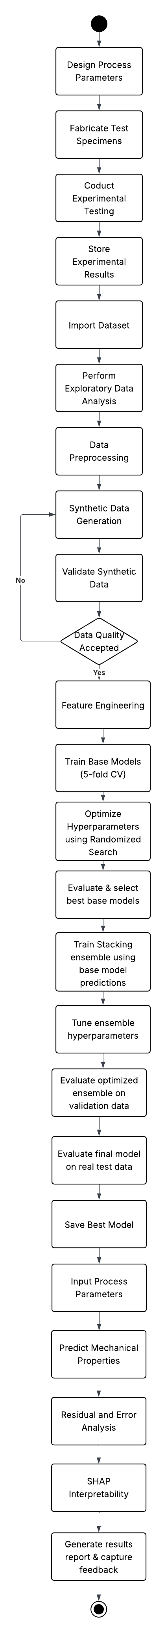

**Figure 4:** Model working described in State Chart Diagram

## Use Case Diagram

**Figure 5:** Use Case Diagram

## Sequence Diagram

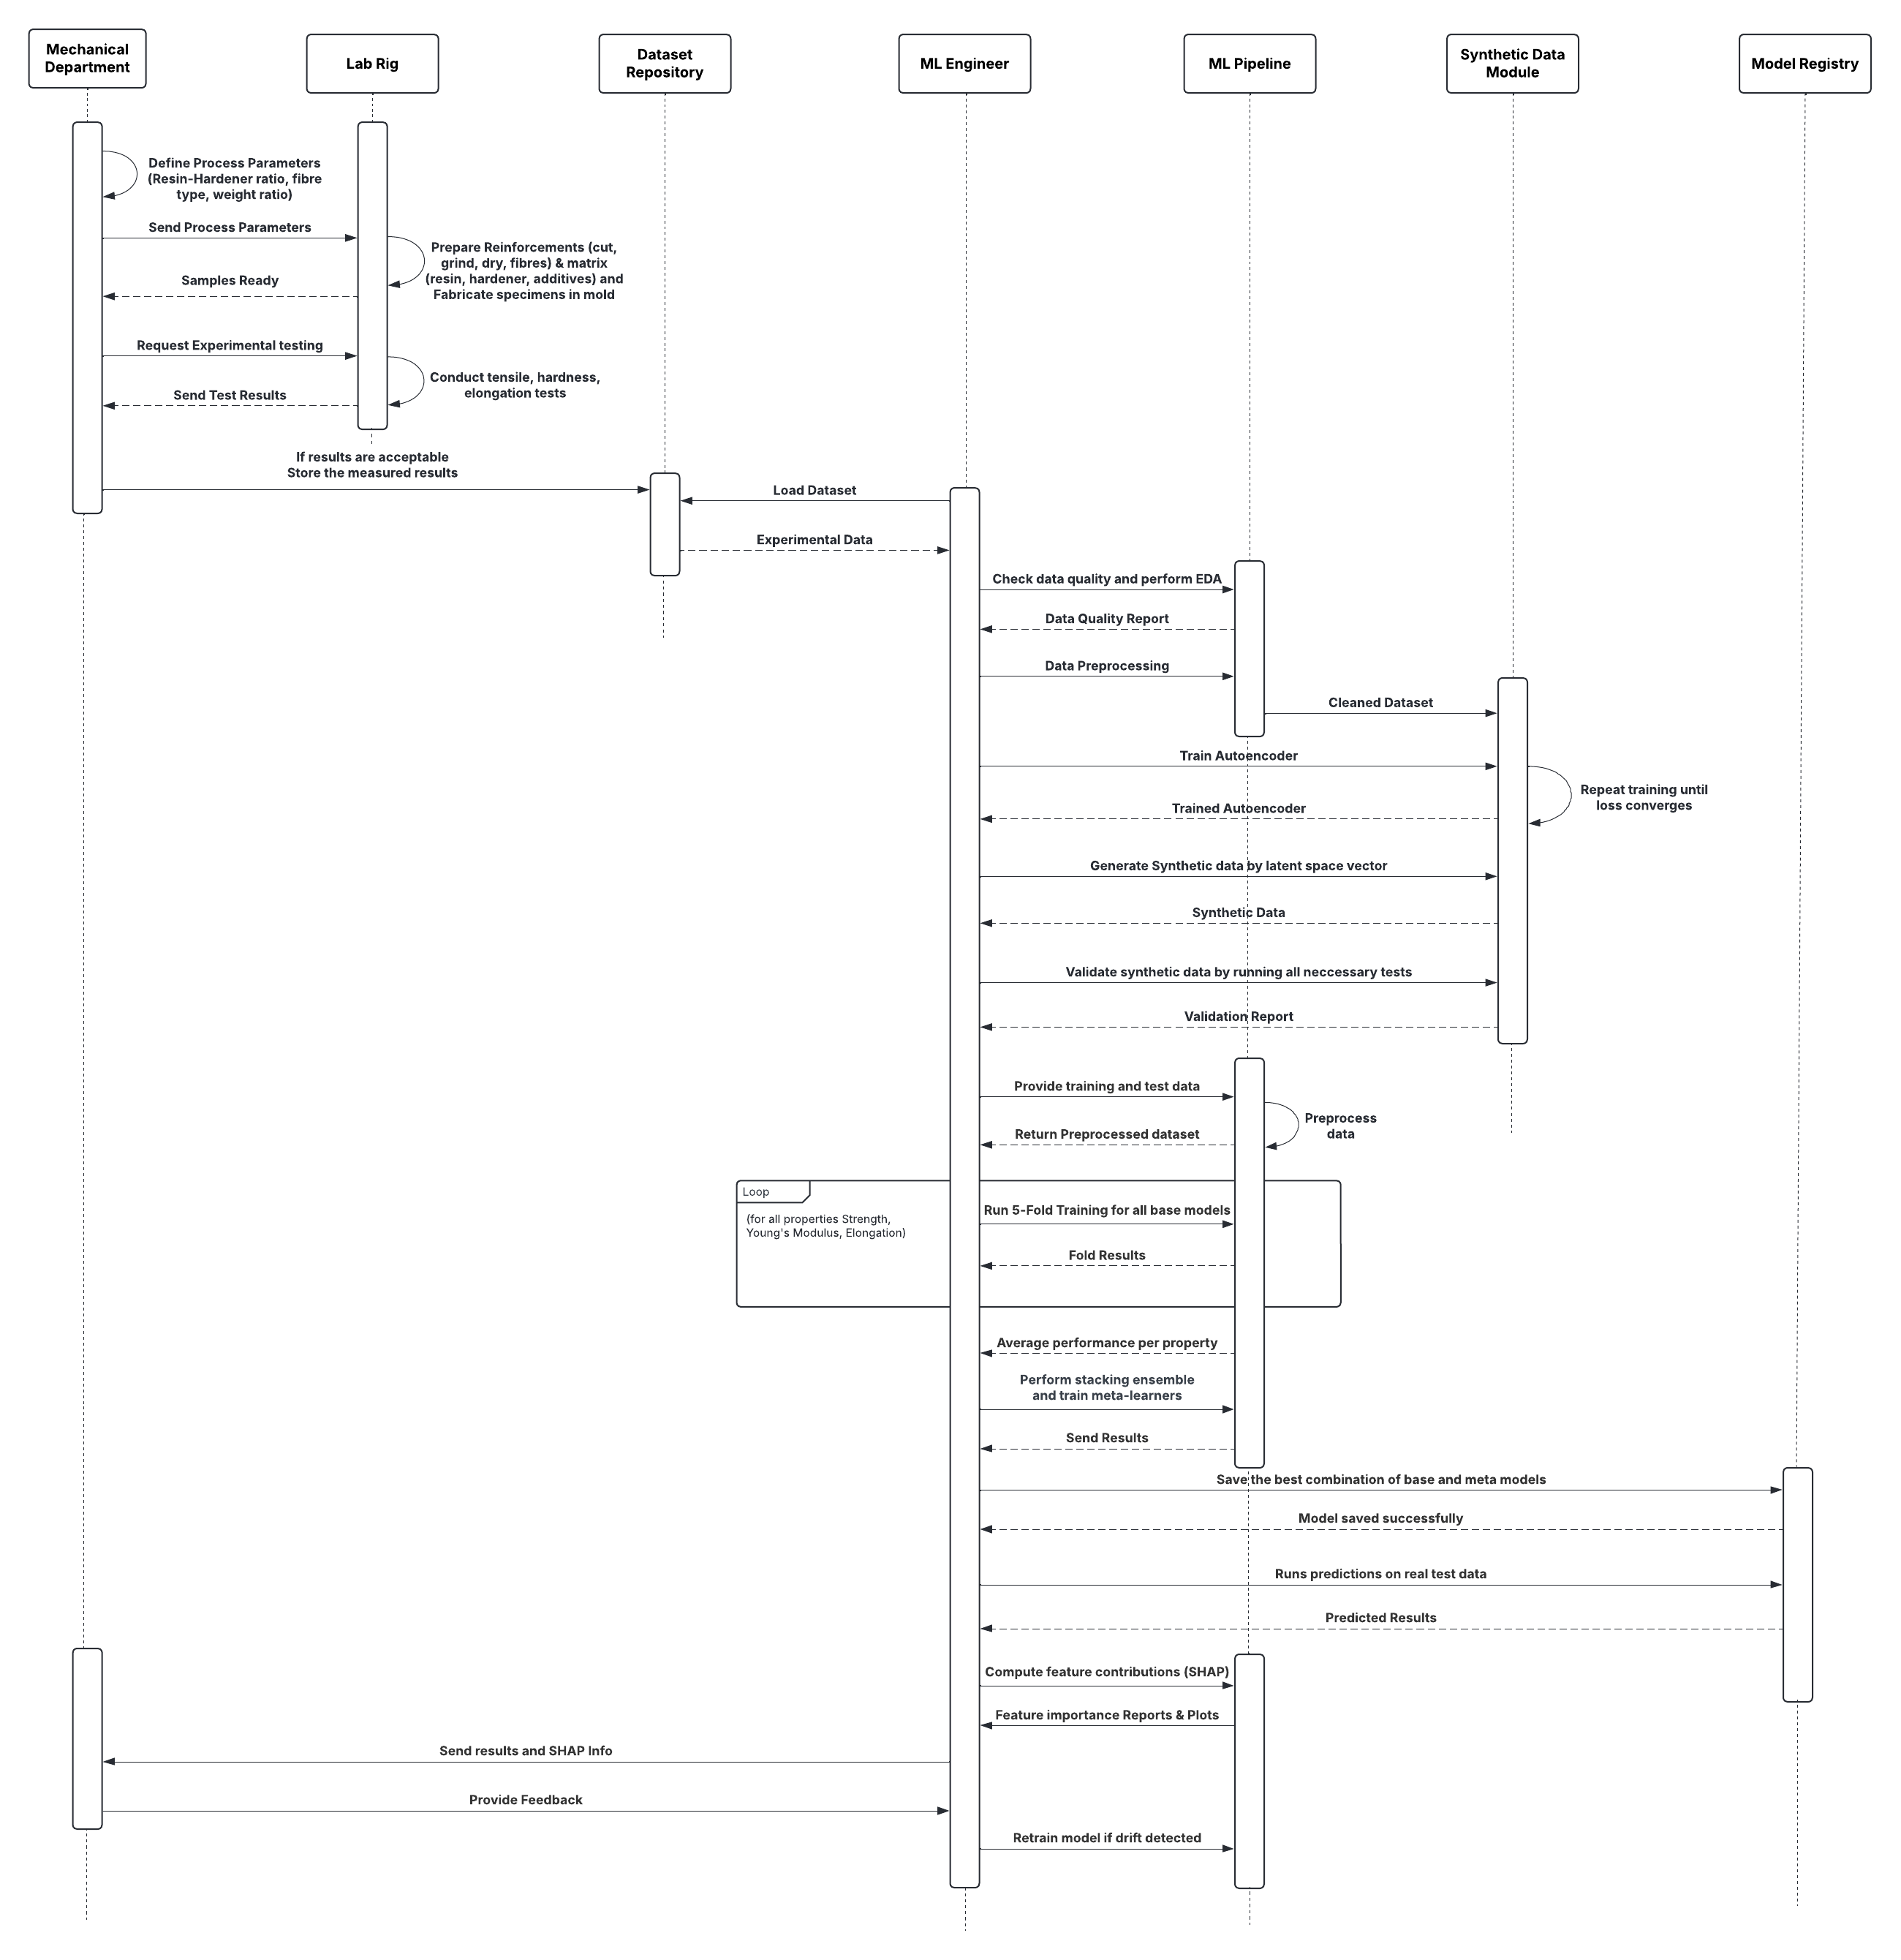

**Figure 6:** Sequence Diagram

**Use Case Templates**

**Table 1: Define Material Mix Parameters**

|  |  |
| --- | --- |
| Use Case ID | UC-01 |
| Use Case Name | Define Material Mix Parameters |
| Purpose | To specify material type and weight composition for specimen fabrication. |
| Primary Actor | Mechanical Engineer |
| Secondary Actor(s) | Lab Technician |
| Trigger | New experiment or mix design needs to be fabricated. |
| Pre-Conditions | Material inventory and equipment must be available. |
| Normal Scenario | 1. Mechanical engineer selects material (e.g. Jute, Banana, Rice Straw).  2. Defines weight percentage for the mix (2-30%).  3. Prepares resin-hardener ratio and processing parameters.  4. Sends finalized parameters to lab technician for fabrication. |
| Post-Conditions | Sends finalized parameters to lab technician for fabrication. |
| Exceptions | 1. Selected material not available in stock.  2. Ratio exceeds safe or recommended limits. |
| Outcome | Validated material mix parameters are approved and sent to the lab. |

**Table 2: Fabricate Specimen**

|  |  |
| --- | --- |
| Use Case ID | UC-02 |
| Use Case Name | Fabricate Specimen |
| Purpose | To prepare physical test specimens based on defined process parameters. |
| Primary Actor | Lab Technician |
| Secondary Actor(s) | Mechanical Engineer |
| Trigger | Mold, resin, hardener, and fibers are available and equipment is operational. |
| Pre-Conditions | Approved fabrication instructions are received. |
| Normal Scenario | 1. Technician prepares fibres (cut, grind, dry).  2. Prepares matrix by mixing resin and hardener.  3. Combines fibre and matrix, pours mixture into Mold.  4. Cures specimen for 48 hours. |
| Post-Conditions | Finished specimen is ready for mechanical testing. |
| Exceptions | 1. Equipment malfunction or mold damage.  2. Improper curing conditions. |
| Outcome | Physical specimens are fabricated as per design. |

**Table 3: Perform Experimental Testing**

|  |  |
| --- | --- |
| Use Case ID | UC-03 |
| Use Case Name | Perform Experimental Testing |
| Purpose | To determine mechanical properties of fabricated specimen. |
| Primary Actor | Lab Technician |
| Secondary Actor(s) | Mechanical Engineer |
| Trigger | Specimen fabrication is complete. |
| Pre-Conditions | Testing machine calibrated and operational. |
| Normal Scenario | 1. Place specimen in testing rig.  2. Conduct tensile, flexural, hardness tests as per ASTM standards.  3. Record stress-strain curves and measured values.  4. Save results in structured dataset. |
| Post-Conditions | Dataset is updated with new experimental results. |
| Exceptions | 1. Test machine failure.  2. Specimen failure due to fabrication defect. |
| Outcome | Verified mechanical property data available for ML pipeline. |

|  |  |  |  |  |  |  |  |  |  |  |  |  |  |  |  |  |  |  |  |  |  |  |  |  |  |  |  |  |  |  |  |  |  |  |  |  |  |  |  |  |  |  |  |  |  |  |  |  |  |  |  |  |  |  |  |  |  |  |  |  |  |  |  |  |  |  |
| --- | --- | --- | --- | --- | --- | --- | --- | --- | --- | --- | --- | --- | --- | --- | --- | --- | --- | --- | --- | --- | --- | --- | --- | --- | --- | --- | --- | --- | --- | --- | --- | --- | --- | --- | --- | --- | --- | --- | --- | --- | --- | --- | --- | --- | --- | --- | --- | --- | --- | --- | --- | --- | --- | --- | --- | --- | --- | --- | --- | --- | --- | --- | --- | --- | --- | --- |
| **Table 4: Generate Synthetic Data**   |  |  | | --- | --- | | Use Case ID | UC-04 | | Use Case Name | Generate Synthetic Data | | Purpose | To expand the dataset and improve ML model training. | | Primary Actor | ML Engineer | | Secondary Actor(s) | None | | Trigger | Dataset too small for robust model training. | | Pre-Conditions | Real experimental dataset must be available. | | Normal Scenario | 1. Train autoencoder model on real dataset.  2. Encode data into latent space and sample new points.  3. Decode to create synthetic samples.  4. Validate synthetic data (distribution, statistics, PCA). | | Post-Conditions | Enriched training dataset is ready for model training. | | Exceptions | 1. Synthetic data fails statistical validation.  2. Autoencoder fails to converge. | | Outcome | Robust dataset created for ML model development. |   **Table 5: Train and Evaluate Model**   |  |  | | --- | --- | | Use Case ID | UC-05 | | Use Case Name | Train and Evaluate Model | | Purpose | To build predictive models for Young’s Modulus, Strength and Elongation. | | Primary Actor | ML Engineer | | Secondary Actor(s) | None | | Trigger | Validated dataset is available. | | Pre-Conditions | ML pipeline is configured and hyperparameters are defined. | | Normal Scenario | 1. Split dataset into training and validation folds (5-fold CV).  2. Train base models (RF, SVR).  3. Tune hyperparameters and evaluate performance.  4. Train stacking ensemble meta-models (GB, XGB).  5. Select best-performing model based on R², RMSE, AAE, ARE.  6. Test final model on real data. | | Post-Conditions | Final trained model is saved and performance metrics are reported. | | Exceptions | 1. Overfitting detected then retrain with adjusted parameters.  2. Model performance below threshold then revisit synthetic data or features. | | Outcome | Reliable predictive model ready for deployment or usage. |  Table 6: Predict Mechanical Properties  |  |  | | --- | --- | | Use Case ID | UC-06 | | Use Case Name | Predict Mechanical Properties | | Purpose | To estimate mechanical properties for new material combinations without physical testing. | | Primary Actor | Researcher | | Secondary Actor(s) | ML Engineer | | Trigger | Researcher wants to test new design. | | Pre-Conditions | Final trained model must be available. | | Normal Scenario | 1. Researcher inputs new material type and weight composition.  2. Model generates predictions for Young’s Modulus, Strength, and Elongation.  3. Predicted results are displayed in tabular and graphical form. | | Post-Conditions | Predicted mechanical properties are available for decision-making. | | Exceptions | Input parameters outside training range | | Outcome | Reliable predictions obtained for design optimization. | |

|  |  |  |  |  |  |  |  |  |  |  |  |  |  |  |  |  |  |  |  |  |  |  |  |  |  |  |  |  |  |  |  |  |  |  |  |  |  |  |  |  |  |  |  |  |  |  |  |  |  |  |  |  |  |  |  |  |  |  |  |  |  |  |  |  |  |  |  |  |  |  |  |  |  |  |  |  |  |  |  |  |  |  |  |  |  |  |  |  |  |  |  |  |  |  |  |  |  |  |  |  |
| --- | --- | --- | --- | --- | --- | --- | --- | --- | --- | --- | --- | --- | --- | --- | --- | --- | --- | --- | --- | --- | --- | --- | --- | --- | --- | --- | --- | --- | --- | --- | --- | --- | --- | --- | --- | --- | --- | --- | --- | --- | --- | --- | --- | --- | --- | --- | --- | --- | --- | --- | --- | --- | --- | --- | --- | --- | --- | --- | --- | --- | --- | --- | --- | --- | --- | --- | --- | --- | --- | --- | --- | --- | --- | --- | --- | --- | --- | --- | --- | --- | --- | --- | --- | --- | --- | --- | --- | --- | --- | --- | --- | --- | --- | --- | --- | --- | --- | --- | --- | --- |
| **Table 7: Interpret Results using SHAP**   |  |  | | --- | --- | | Use Case ID | UC-07 | | Use Case Name | Interpret Results using SHAP | | Purpose | To interpret model results and understand feature contributions. | | Primary Actor | ML Engineer | | Secondary Actor(s) | Researcher | | Trigger | Predictions are generated. | | Pre-Conditions | SHAP explainer available for final model. | | Normal Scenario | 1. Compute SHAP values for predictions.  2. Display global feature importance plot.  3. Show local explanation for each prediction (force or waterfall plot). | | Post-Conditions | Researcher gains insight into which factors drive predictions. | | Exceptions | 1. SHAP explainer fails due to model mismatch.  2. Inconsistent SHAP behavior. | | Outcome | Transparent and interpretable results provided. |   **Table 8: Feedback & Model Retraining**   |  |  | | --- | --- | | Use Case ID | UC-07 | | Use Case Name | Feedback & Model Retraining | | Purpose | To continuously improve model accuracy with new experimental results. | | Primary Actor | Researcher | | Secondary Actor(s) | ML Engineer | | Trigger | New physical test results become available. | | Pre-Conditions | Model retraining pipeline must be functional. | | Normal Scenario | 1. Researcher logs new results into dataset.  2. ML engineer retrains model with updated data.  3. Updated model is validated and stored. | | Post-Conditions | New model replaces old version. | | Exceptions | 1. Retrained model underperforms then rollback to previous model. | | Outcome | Model stays updated and improves over time. |   **Test Case Templates** Table 1: Metakaolin Enhanced Mix  |  |  | | --- | --- | | Test Case ID | TC-1 | | Objective | Predict mechanical properties for a jute fiber composite with 10% weight composition. | | Scenario | Concrete sample prepared using Metakaolin as the SCM. | | Pavement Recommendation | Low-volume roads | | Compressive Strength | 7–15 MPa | | Remarks | This mix is suitable for areas with occasional vehicular traffic and moderate rainfall. Metakaolin improves density and mechanical strength. | | Observed Output | Predicted compressive strength averaged 13 MPa, confirming suitability for low-traffic pavements. Model interpretability (SHAP) highlighted curing age and metakaolin content as key contributors. |  Table 2: Fly Ash Enhanced Mix  |  |  | | --- | --- | | Test Case ID | TC-2 | | Objective | Identify pavement type for Fly Ash-enhanced NFC in similar traffic conditions. | | Scenario | Concrete sample prepared using Fly Ash. | | Pavement Recommendation | Low-volume roads | | Compressive Strength | 7–15 MPa | | Remarks | Fly Ash improves sustainability and slightly enhances permeability while maintaining adequate strength for low-traffic routes. | | Observed Output | Achieved predicted strength of 11.5 MPa. Fly ash addition slightly reduced early strength but remained within target for low-volume road applications. |  Table 3: Silica Fume Mix  |  |  | | --- | --- | | Test Case ID | TC-3 | | Objective | Assess suitability of NFC with Silica Fume for higher structural and drainage demands. | | Scenario | Concrete sample prepared using Silica Fume. | | Pavement Recommendation | Parking lots and loading zones | | Compressive Strength | 7–12 MPa | | Remarks | Silica Fume improves paste bonding and strength, ideal for parking areas requiring better load resistance and permeability balance. | | Observed Output | Strength predicted at 12 MPa. The model indicated silica fume improves paste bonding, making the mix well-suited for load-bearing areas like parking zones. |  Table 4: Rice Husk Ash Mix  |  |  | | --- | --- | | Test Case ID | TC-4 | | Objective | Identify pavement category based on comfort and light load conditions. | | Scenario | Concrete sample prepared using Rice Husk Ash. | | Pavement Recommendation | Driveways and footpaths | | Compressive Strength | 5–10 MPa | | Remarks | Suitable for pedestrian pathways or light vehicle usage where comfort and drainage are priorities. RHA promotes eco-friendliness and workability. | | Observed Output | The ML model estimated 9 MPa compressive strength. Suitable for footpaths or light-use driveways, RHA provided balanced strength with eco-friendly composition. |   **Model Interpretability Using SHAP**  To enhance trust and interpretability in our machine learning-based prediction system, we incorporated SHAP (Shapley Additive Explanations), a model-agnostic explainability technique. SHAP assigns each feature an importance value for a particular prediction, based on cooperative game theory. This makes it possible to understand the influence of each SCM such as Fly Ash, Silica Fume, Metakaolin, and Rice Husk Ash on the predicted compressive strength of NFC.  We utilized two primary SHAP visualizations:   * **Waterfall Plot**: This plot is used to explain a single prediction by showing how the value moves from the base value (the average prediction) to the final output. It helps visualize how each input feature either increases or decreases the predicted strength.         **Figure 8:** SHAP Waterfall Plot showing how each input contributes to the predicted compressive strength   * + **Force Plot**: This is an interactive visualization used to explain individual or multiple predictions. It shows the cumulative contribution of all features, making it easier to detect patterns or inconsistencies across different data samples.     **Figure 9**: SHAP Local Interpretation Plots for Strength    **Figure 10** SHAP Local Interpretation Plots for Elongation    **Figure 12:** SHAP Local Interpretation Plot for Young’s Modulus  These explainability tools bridge the gap between complex ensemble models (like XGBoost and Random Forest) and practical engineering decisions. Civil engineers and researchers can use these visual insights to validate model predictions and understand how variations in mix composition impact final strength. This transparency supports better decision-making and encourages adoption of AI driven methods in sustainable construction. |

|  |
| --- |
| **Novel/New Features of your invention** |
| 1. **Seamless Integration of Experiments and Machine Learning** - The system combines physical experimental testing with a machine learning predictive model in one workflow. This reduces the need for repeated physical trials for every new material combination. 2. **Synthetic Data Augmentation for Small Datasets** - An autoencoder-based synthetic data generator enhances a very small experimental dataset. The synthetic data is validated using distribution checks, PCA visualization, and statistical tests before merging with real data. 3. **Train on Synthetic, Test on Real Paradigm** - The model is trained on the synthetic + real dataset but evaluated only on real samples, ensuring true generalization, no data leakage and trustworthy predictions. 4. **Multi-Output Regression with Ensemble Stacking** - Predicts three mechanical properties simultaneously such as Young’s Modulus, Strength, and Elongation by using a stacked ensemble of base models and meta-learners, capturing complex feature interactions. 5. **Model Interpretability with SHAP** - Provides global and local explanations of feature importance, helping researchers understand which input parameters influence predictions for each material property. 6. **Generalizability to Other Materials** - The workflow is adaptable to other composites, such as cementitious or metal-matrix materials, making it broadly applicable. |

|  |
| --- |
| **Advantages of your invention** |
| * **Saves Time and Reduces Experimental Effort -** Predictive modeling reduces the number of physical specimens and tests required, accelerating the research process. * **Cost-Effective Material Research** - Fewer experiments translate to lower material costs, labour, and operational expenses. * **Reliable Predictions from Limited Data** - Even with a small experimental dataset, the system produces accurate predictions, enabling confident decision-making for new material compositions. * **Supports Informed Design Decisions** - Interpretable outputs allow researchers to identify key factors influencing material properties, improving experiment planning and material optimization. * **Applicability Across Multiple Materials** - While optimized for natural fibre polymer composites, the approach can be applied to other composite systems, broadening its utility. * **Minimizes Failed Experiments** - By accurately forecasting mechanical properties, the system reduces the risk of wasteful or unsuccessful experimental trials. |

|  |
| --- |
| **Limitations of your invention** |
| * **Dependence on Initial Experimental Data Quality** - The system’s accuracy relies on the quality and reliability of the original experimental dataset; poor data may reduce performance. * **Synthetic Data Limitations** - Synthetic data may not fully capture rare behaviors or extreme material properties not present in the original dataset. * **Computational Complexity** - The stacked ensemble with multiple base models and meta-learners requires significant computational resources for training. * **Generalization Boundaries** - Predictions may be less accurate for novel or extreme material compositions outside the trained range, requiring physical validation. * **Requires Domain Knowledge** - Interpreting SHAP outputs and applying insights still requires material science expertise limiting use by non-specialists. |

1. **Level of development of your invention**

- **Initial**

1. **List of competitor companies and their product/process**
2. **Prior use, sale, or disclosure**

|  |  |
| --- | --- |
| Has the invention been published/sold/disclosed before? | NO |
| Do you intend to publish/sell/disclose the invention? | YES |

1. **Regions of commercialization of your invention (To be discussed)**

|  |  |  |
| --- | --- | --- |
| India |  | |
| Patent Cooperation Treaty (PCT) member countries |  |  |
| Individual foreign countries,  please indicate the names | If there are any countries which are not include in the attached PCT Member Countries list, please indicate here. | |

**Additional information and documentation, if any, may also be provided.**

**CRITERIA FOR START UP**

The criteria for claiming ‘start-up’ status are as follows:

* More than 5 years have not lapsed from date of incorporation / registration;
* Turnover for any of the 5 financial years has not exceeded 25 crores; and
* It is working towards development and commercialization of a new product/service/process

A start-up can be a private limited company, a registered partnership firm or a limited liability partnership.

Please note that documentary evidence will have to be filed in case the Applicant wishes to claim the ‘start up’ status.

**CRITERIA FOR SMALL ENTITY**

The criteria to claim “small entity” is as follows:

* in case of an enterprise engaged in the manufacture or production of goods, where the investment in plant and machinery does not exceed INR 10 crores; and
* in case of an enterprise engaged in providing or rendering of services, where the investment in equipment is not more than INR 5 crores.

Please note that documentary evidence will have to be filed in case the Applicant wishes to claim the ‘small entity’ status.